# Giving access to the database

1. Open Microsoft SQL Server Management Studio.
2. Enter the credentials.
3. On the “Object Explorer” pane on your left side, expand “Security” tab under the main server,”Ist-rs-sql1.ad.syr.edu, 1533”.
4. Right click on “Logins”, the first option.
5. Select “New Login..”.

The Login creation pane looks like the below.

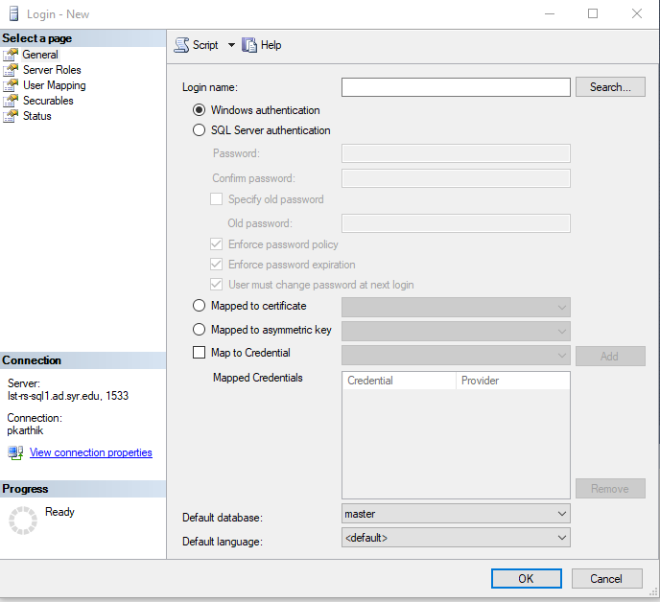

1. Under the “General” tab, type in the desired login name in the “Login name” text box.(Syracuse netid is preferred)
2. Select “SQL Server authentication” radio button in the next section. On the option below, the default would be “Windows authentication”. (SQL server authentication is preferred as once the login becomes unnecessary it will be easier to delete the login. In Windows authentication we have to contact the ITS to delete the login.)
3. Enter the Password in the “Password” text box. In addition, enter it again in the “Confirm password” text box.
4. In the below check box section select “Enforce password policy”, “Enforce password expiration”, “User must change password at next login” options.(“User must change password at next login” will ask the user to set his password the first time he logs in.)
5. Leave out the rest of the options and come to “Default database” selection box.
6. Select the desired database you want the user to access. Usually set to “Pecan Street”.

After finishing the above steps the General tab should look as the below.

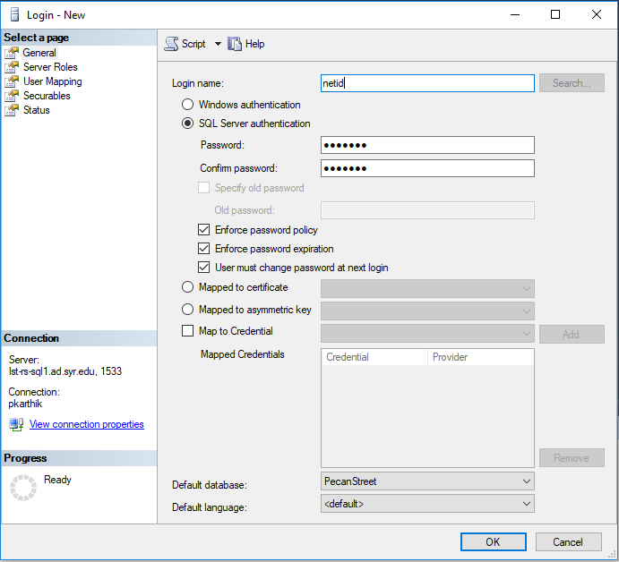

1. Select the “Server Roles” page from the “Select a page” option found on the left side of the “Login-New” window.
2. Under the “Server roles”, select the “public” check box. The same is the default. “public” server role is the most basic server role.

After the completion the “Server Roles” page looks like the below.

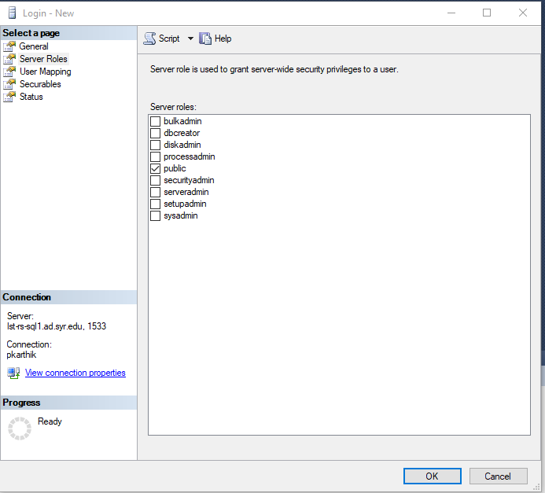

1. Select the “User Mapping” page in the “Select a page”
2. Select the database that you want the user to access under the “Users mapped to this login:” section.(Usually the “Pecan Street” check box is selected)
3. Under the “Database role membership for:Pecan Street” select the check boxes that are desirable.(If you are giving only the reading permission, select the “db_datareader” and ”db_denydatawriter” check boxes)
4. Select “OK”.

The “User Mapping” page will look as the below.

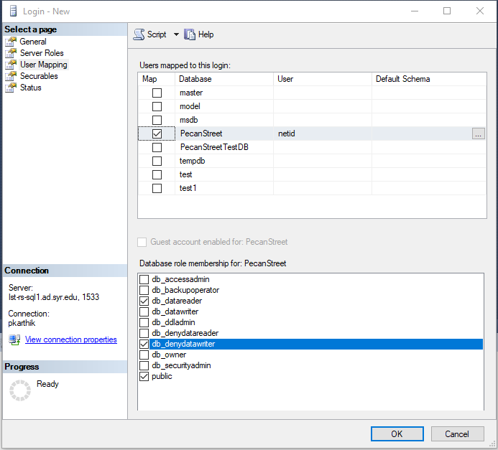

**The login is successfully created.**